1. Let’s discuss the field starting with “x-“.
2. Even though OpenAPI Specification tries to accommodate all the use cases, but at some points of time, there may be some scenarios where we may feel that if we have flexibility of defining our own custom objects/fields inside OpenAPI specification, it would be helpful.
3. 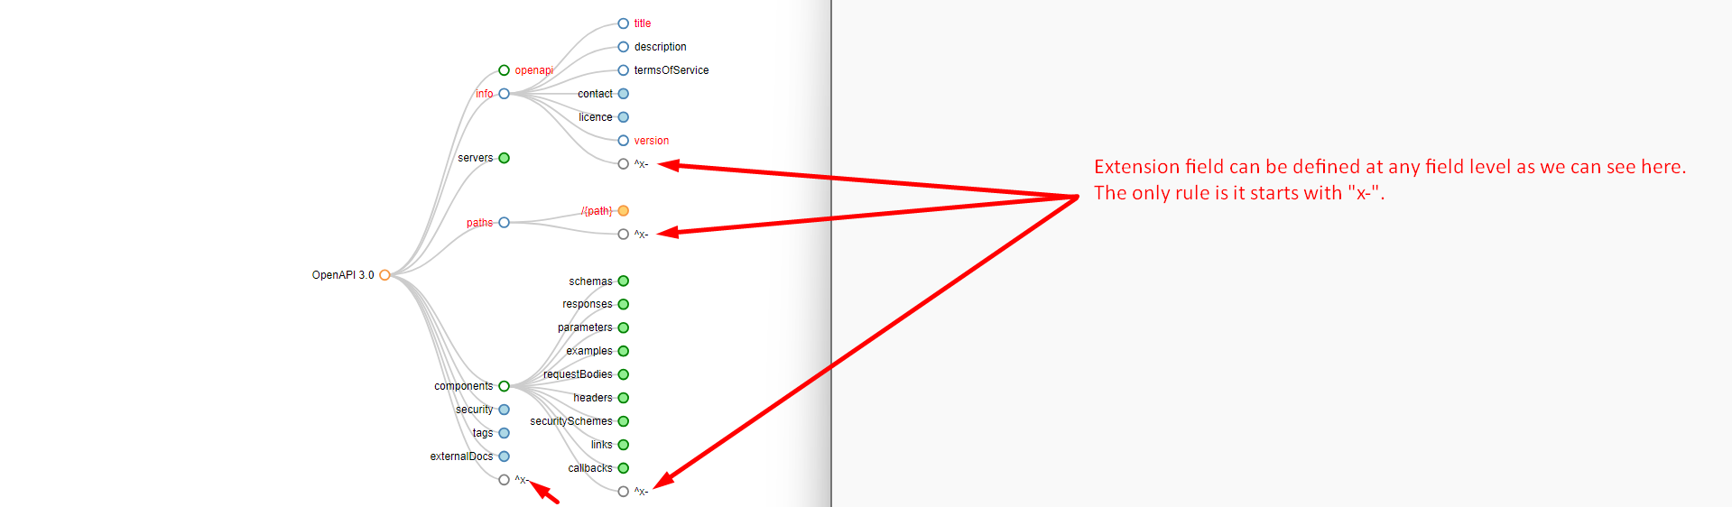
4. 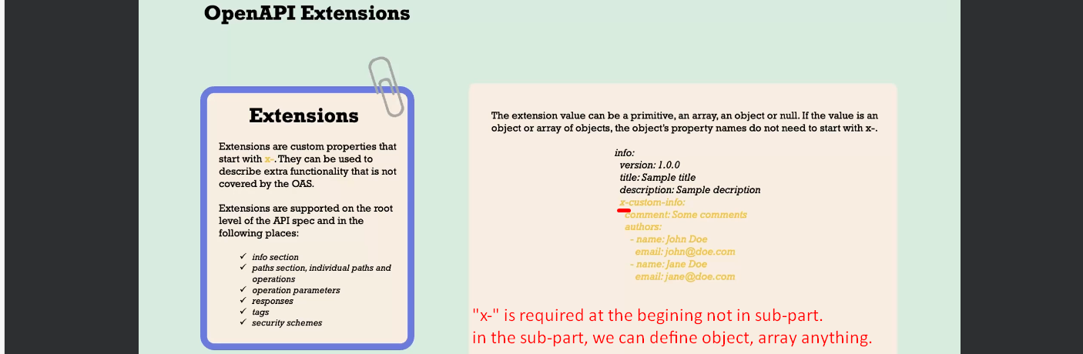
5. 